Question 2b.

Implied Volatility Vs. Strike Price

r = 0:04; S0 = 100; Y0 = log(0:15);

alpha = 10; beta = 4; p = -0:2;

T = 0.5 and m = log 0.15

Using Monte Carlo Simulation – 25000 paths

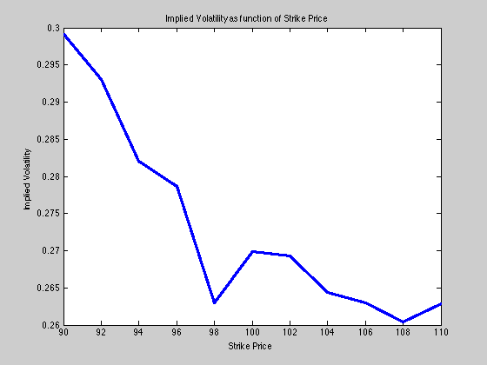

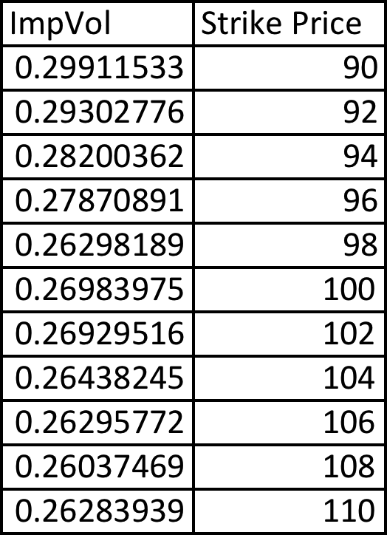

p = 0;

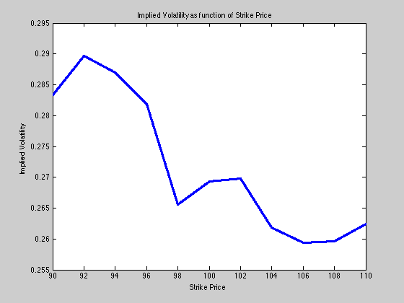

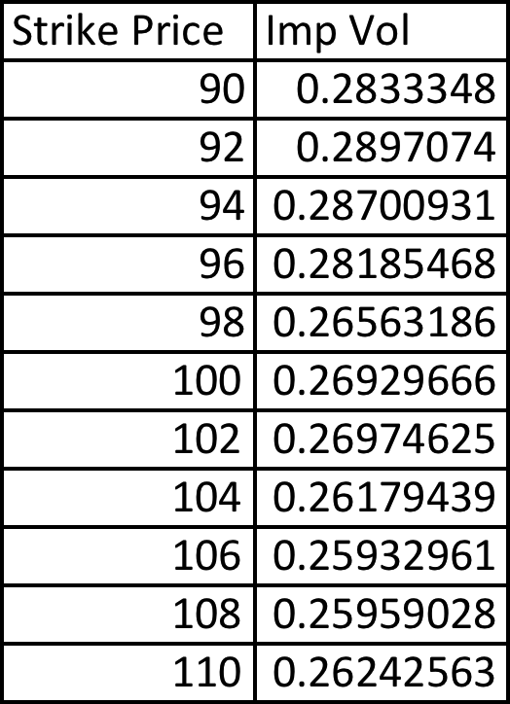

p=0.2